Sprint Plan 2

**Product:** SquadUp

**Team:** The Big Ballers

**Completion date:** July 9th

**Revision number:** 1.0

**Revision date:** 7/2/2018

**Goal:**

To integrate functionality between the server and client for the web app. The authentication of the users, and the data from MongoDB to the events/map page.

**Tasks for user stories:**  User Story 1: As a developer, I want to connect the server with the client so data can be passed back and forth. (5)

* + Task 1: Link the Google Authentication page with the landing page after you log in.

**Hours estimated:** 2

* + Task 2: Create a basic button that links with Google Authentication on the page.
    - **Hours estimated:** 1
  + Task 3: Create a link for every page being used.
    - **Hours estimated:** 2
  + Task 4: Test retrieving data from MongoDB and displaying it on the page.
    - **Hours estimated:** 5
  + Task 5: Test sending information from Page to DB.
    - **Hours estimated:** 4
  + Task 6: Create a logout button that works.
    - **Hours estimated:** 4

**Total Time for User Story**: 18 hours.

User Story 2: As a user, I want to be able to view the map of all the parks and games available in my local area. (Test case: UCSC fields and outside basketball courts). (13)

* + Task 1: Send park data from database onto maps page
    - **Hours estimated**: 2
  + Task 2: Create events database.
    - **Hours estimated**: 2
  + Task 3: Create ArrayList to view the events.
    - **Hours estimated**: 6
  + Task 4: Implement the Google Map API on the maps page.
    - **Hours estimated**: 2
  + Task 5: Read in JSON data and use it on the Google Map API.
    - **Hours estimated:** 5

**Total Time for User Story**: 17 hours.



**Team roles:**

* Zahir Yahya: Front/Back end Dev
* Sean Woods: Front/Back end Dev
* Chuangbo Tong: Front/Back end Dev
* Shyaan Khan: Front/Back end Dev
* Collin Fulcher: Front/Back end Dev
* Tyler Frick: Front/Back end Dev

**Initial task assignment:**

* Zahir Yahya:
  + User Story 1
    - Link the google auth page.
    - Create a basic button that links with google auth on the page.
* Sean Woods:
  + User Story 1
    - Create link for all pages.
    - Test retrieving data from MongoDB and displaying it on the page.
* Chuangbo Tong:
  + User Story 1
    - Create a logout button that works.
    - Test sending information from Page to DB.
* Shyaan Khan:
  + User Story 1
    - Create a logout button that works.
    - Test sending information from Page to DB.
* Collin Fulcher:
  + User Story 1
    - Link the google auth page.
    - Create a basic button that links with google auth on the page.
* Tyler Frick:
  + User Story 1
    - Create link for all pages.
    - Test retrieving data from MongoDB and displaying it on the page.

**Initial burnup chart:**

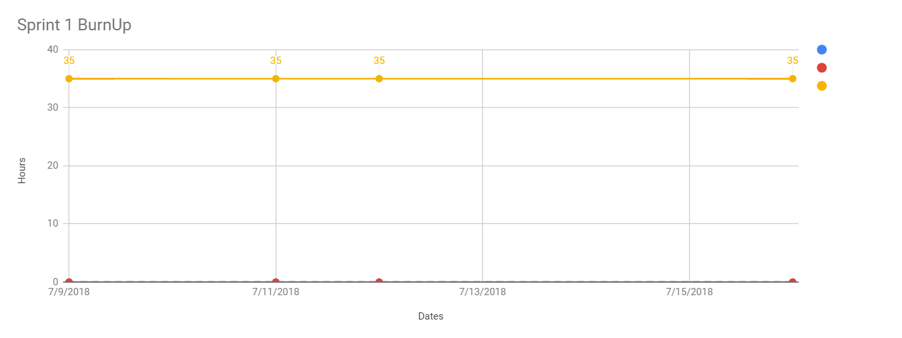



**Initial scrum board:**

https://trello.com/b/5uzWWJz7/squadup-scrum-board



**Scrum times:**

Monday after T.A. meeting: 1:00 PM

Wednesday After class: 12:30 PM

Thursday: After TA meeting 1:00 PM